Logic Gates Questions

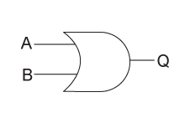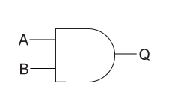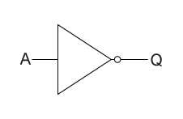 OR Gate AND Gate NOT Gate

# Questions

1. Draw a truth Table for each of the following Boolean expressions
   1. NOT(A OR B)

|  |  |  |  |
| --- | --- | --- | --- |
| A | B | A OR B | NOT |
| 0 | 0 | 0 | 1 |
| 0 | 1 | 1 | 0 |
| 1 | 0 | 1 | 0 |
| 1 | 1 | 1 | 0 |

1. NOT(A) OR NOT (B)

|  |  |  |  |
| --- | --- | --- | --- |
| A | B | A NOT B | A AND B |
| 0 | 0 | 1 | 0 |
| 0 | 1 | 1 | 0 |
| 1 | 0 | 1 | 0 |
| 1 | 1 | 0 | 1 |

1. A AND NOT(B)

|  |  |  |  |
| --- | --- | --- | --- |
| A | B | A AND B | A NOT B |
| 1 | 0 | 0 | 1 |
| 1 | 1 | 1 | 0 |
| 0 | 1 | 0 | 1 |
| 0 | 0 | 0 | 1 |

* 1. A AND NOT(B OR C)

|  |  |  |  |  |  |
| --- | --- | --- | --- | --- | --- |
| A | B | c | B OR C | Not(b or c) | And |
| 1 | 0 | 0 | 0 | 1 | 1 |
| 1 | 1 | 0 | 1 | 0 | 0 |
| 0 | 1 | 0 | 1 | 0 | 0 |
| 0 | 0 | 0 | 0 | 1 | 0 |
| 1 | 0 | 1 | 1 | 0 | 0 |
| 1 | 1 | 1 | 1 | 0 | 0 |
| 0 | 1 | 1 | 1 | 0 | 0 |
| 0 | 0 | 1 | 1 | 0 | 0 |

1. Draw the logic circuits for each of the above expressions
2. Draw the truth tables for
   1. A AND (B OR C)
   2. (A AND B) OR (A AND C)
   3. Calculate 3x(5+6) and 3x5 + 3x6



A

B

C

Q

P

* 1. What do you notice?

1. Look at the logic circuit below:

Complete a truth table for this circuit.

# Extension Task

1. Draw a logic circuit for A OR (B AND C) OR D
2. How many rows must the truth table have?
3. Complete the truth table
4. De Morgan’s Law says NOT(B OR C) is the same as NOT(B) AND NOT(C). Show this is true by completing the truth table.
5. The NAND gate is an important type of gate and is used to create a circuit called a flip-flop. Investigate what is a flip-flop, what does it do and why is it important?